Environmental monitoring refers to the process of observing and collecting data about the environment to assess its quality and make informed decisions about its preservation and management. This monitoring can encompass various aspects of the natural world, including air, water, soil, ecosystems, and more. The data gathered through environmental monitoring helps scientists, governments, and organizations understand the state of the environment, track changes over time, and take appropriate actions to address environmental issues. Here are some key aspects of environmental monitoring:

1. Air Quality Monitoring: This involves measuring pollutants and gases in the atmosphere, such as carbon dioxide, particulate matter, and volatile organic compounds. Monitoring air quality is essential for public health and for assessing the impact of human activities on the atmosphere.

2. Water Quality Monitoring: This includes assessing the chemical, physical, and biological characteristics of water bodies like rivers, lakes, and oceans. It helps identify pollution sources, detect changes in water quality, and ensure safe drinking water and aquatic ecosystem health.

3. Soil Monitoring: Monitoring soil conditions is important for agriculture, land use planning, and environmental protection. It assesses soil composition, contaminants, and erosion rates.

4. Biodiversity and Ecosystem Monitoring: Tracking the health and diversity of ecosystems is crucial for preserving biodiversity and understanding the impacts of climate change and habitat loss.

5. Weather and Climate Monitoring: Collecting data on temperature, precipitation, humidity, and other meteorological parameters is fundamental for studying climate patterns and predicting weather events.

6. Noise and Light Pollution Monitoring: Assessing noise and light pollution levels in urban and natural areas can help mitigate the adverse effects on human health, wildlife, and ecosystems.

7. Hazardous Waste Monitoring: Monitoring hazardous waste disposal sites and industrial facilities helps ensure compliance with environmental regulations and prevent contamination.

8. Remote Sensing: Using satellites and other remote sensors to gather data on a large scale, such as monitoring deforestation, tracking ice cap melt, or assessing urban expansion.

9. Wildlife Tracking: Employing GPS and other technologies to monitor the movements and behaviors of wildlife for research and conservation purposes.

10. Environmental Data Analysis: Collecting data is only the first step. Analyzing the data and making it available to policymakers, researchers, and the public is crucial for informed decision-making.

Environmental monitoring is vital for understanding the state of the planet, identifying emerging environmental issues, and implementing measures to protect and preserve the environment for current and future generations. It plays a central role in addressing challenges such as climate change, pollution, habitat loss, and resource management.

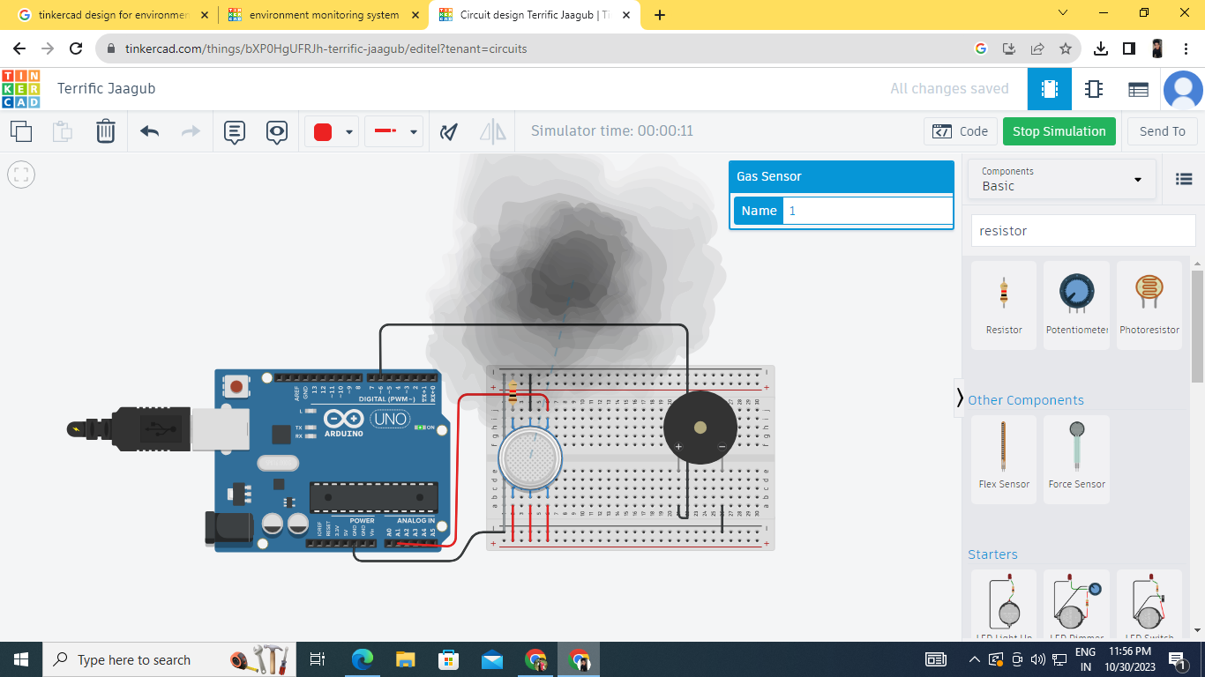

LINKIN : <https://www.tinkercad.com/things/bXP0HgUFRJh-terrific-jaagub/editel?tenant=circuits>

// C++ code

//

/\*

Environment monitoring system

\*/

int gassensor = 0;

void setup()

{

pinMode(A1, INPUT);

Serial.begin(9600);

pinMode(6, OUTPUT);

}

void loop()

{

gassensor = analogRead(A1);

Serial.println(gassensor);

if (gassensor > 200) {

tone(6, 523, 1000); // play tone 60 (C5 = 523 Hz)

}

delay(10); // Delay a little bit to improve simulation performance

}// C++ code

//

/\*

Environment monitoring system

\*/

int gassensor = 0;

void setup()

{

pinMode(A1, INPUT);

Serial.begin(9600);

pinMode(6, OUTPUT);

}

void loop()

{

gassensor = analogRead(A1);

Serial.println(gassensor);

if (gassensor > 200) {

tone(6, 523, 1000); // play tone 60 (C5 = 523 Hz)

}

delay(10); // Delay a little bit to improve simulation performance

}

